

**Grade VI CYCLE TEST 1 Full Mark 20**

**Name: Social Science Date: 18.8.25**

**SECTION A – Multiple Choice Questions *(1 mark × 10 = 10 marks)***

**Choose the correct answer:**

1. The earliest period of human history is called the:  
    a) Mesolithic Age  b) Neolithic Age

c) Palaeolithic Age  d) Chalcolithic Age

1. The earliest humans lived in:

     a) Villages  b) Caves  c) Cities  d) Houses of bricks

3. Which type of tools did early humans use in the Old Stone Age?  
 a) Iron tools  b) Polished stone tools

c) Rough stone tools  d) Bronze tools

4.The Middle Stone Age is also known as the:  
 a) Neolithic Age b) Chalcolithic Age c) Mesolithic Age d) Metal Age

5.In which age did humans start growing crops?  
 a) Palaeolithic b) Mesolithic c) Neolithic d) Chalcolithic

6.Which activity became possible after the invention of the wheel?  
 a) Cooking food b) Making pottery  
 c) Travelling and transport d) Weaving cloth

7. Cave paintings of early humans mainly show:  
 a) Animals and hunting scenes  
 b) Rivers and mountains  
 c) Tools and weapons  
 d) Houses and roads

8. Since both stone and ___________ were used, this period is called

the Chalcolithic age.

a) Copper  b) Gold  c) Iron  d) Silver

**SECTION B Case study *(4 mark )***

**8. Read the passage and answer the following questions:**

Early humans in the Neolithic Age began to produce their own food. They grew wheat, barley, rice, and pulses. They domesticated animals like goats, sheep, and cattle. Tools like sickles were used to cut crops, while grinding stones were used to make flour. This change led to settled life and the development of permanent houses made of mud and straw.

**Questions:**a)Imagine you are a Neolithic farmer. Explain how the invention of the sickle might have changed the way you harvest crops compared to using bare hands. *(1 marks)*

b) The passage says people started living in permanent houses made of mud and straw. What problems and advantages do you think such houses had?(2 Mark)

 c) Name two tools mentioned in the passage. (1 mark)

**Section C (2 marks)**

**9. Picture based question** 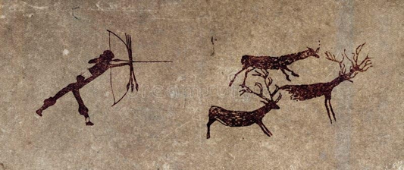

Study the image of a cave painting from Bhimbetka showing a group of people hunting a bison. What does this painting tell us about the lifestyle of early humans? (write own answer)

**SECTION D – Short Answer Questions *(3 marks × 2 = 6 marks)***

10.Mention three ways in which fire was useful to early humans.

11.Write any three differences between the Palaeolithic and Neolithic

Ages.